Castle View Athletic Advertising Plans
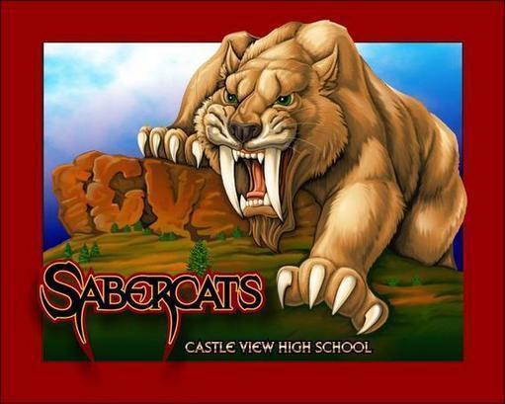

Gymnasium Advertisement
Castle View High School gym and fields host several events for not only Castle View High School but Castle Rock Middle School, Castle Rock Rec, Raptors, and Gold Crown. With this option, your advertisement will be seen by several hundred parents and athletes along with our performing arts community. You receive a 2’x4’ colored banner on the north or east gym wall.
- One Calendar Year - $600
- Two Calendar Years - $1,000

Sabercatsports.org
Castle View Athletics is providing an opportunity to advertise for your local business. Our new and improved sabercatsports.org is the main communication source of all athletic information for Castle View High School. This past school year sabercatsports.org received close to half a million hits. Please provide the below.
- Advertising Artwork
- Logo & Font size for advertisement: 1.5 inches by 1.5 inches
- Any color or multiple colors are available
- Cost $250 / One Calendar Year Contract

- Pride Signs
Pride Signs are 4’x8’ banners that will be placed on the exterior of the school near the turf, football, tennis, soccer, baseball and softball facilities. These banners are professionally made for the Castle Rock weather elements. Castle View Athletics hosts several events for not only Castle View High School but Castle Rock Middle School, Castle Rock Rec, Raptors, and Gold Crown. With this option, your advertisement will be seen by several hundred parents and athletes along with our performing arts community.
- One Calendar Year Contract - $600
- Two Calendar Year Contract - $1,000

Sabercat Home Sporting Events Produced by School Space Media
School Space Media is a live streaming service that we have partnered with to broadcast home football, softball, baseball, hockey, boys and girls basketball, boys and girls soccer and boys and girls lacrosse games. Your company logo will go on the broadcast as well as announced by the live stream announcers during the game. With less fans in attendance at sporting events due to current health safety guidelines more and more fans will take advantage of watching the games live virtually.
- $100 per game
- $400 for five games (you pick the games)
- $1,000 all games for the 2020/21 school year

Community Partner Grand Slam Package
This promo pack gets you everything for a sweet deal. You will receive banners in our gym and on our field fences, along with your logo with contact information on sabercatsports.org, your business announced at all football, softball, baseball, boys/girls soccer, boys/girls basketball and boys/girls lacrosse games along with being promoted on all School Space Media live stream games.
- One Calendar Year Contract - $1,500
- Two Calendar Year Contract- $3,000

Game Day Sponsor Plan
This unique advertising opportunity allows all fans (parents, students and community members) into a game for free, on you. You can choose a single game or the entire season from the below menu. With this option, you can set up a table at the game sharing information about your business and a fan giveaway.
- Volleyball $500 a Game / $3,500 / 8 home game season
- Boys Basketball $1,000 a Game / $6,500 / 8 home game season
- Girls Basketball $750 a Game / $5,000 / 8 home game season
- Boys Soccer $500 a Game / $2,000 / 5 home game season
- Girls Soccer $500 a Game / $2,000 / 5 home game season
- Boys Lacrosse $500 a Game / $2,000 / 5 home game season
- Girls Lacrosse $500 a Game / $2,000 / 5 home game season

Thank you for sponsoring Castle View High School Athletics!

Welcome to Sabercat Nation!
Castle View High School Athletic Advertising Contract
Contact Name__________________________________Date__________
Business Name__________________________________
Advertising Plan __________________________________
Phone Number__________________________________
Email Address___________________________________

