CASHLESS TICKET SALES ARE HERE!
Online Ticketing is here in Jeffco!
Options to Purchase a Ticket:
- Go to your schools Athletics website & click the TICKETS tab
- Download the Home Town Ticket App
- Scan the QR Code Below
- Credit Cards will be accepted onsite
*** In order to avoid waiting in line to purchase a ticket via a credit card, pre-purchase tickets using options 1-3 (outlined above) will allow you scan your ticket upon arrival for admittance without waiting in line.
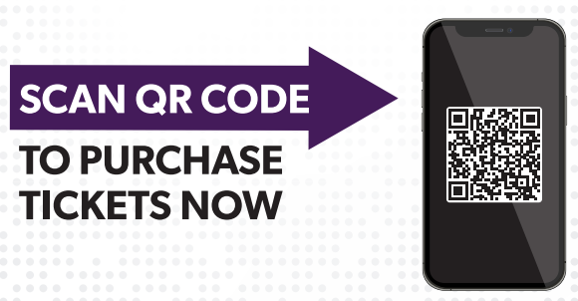

NO CASH OPTION WILL BE AVAILABLE

