ATHLETICS POWERTEACHER/GRADEBOOK INSTRUCTIONS
These instructions are based on using Safari as the web browser. Other browsers may vary.

Step 1. Log into PowerTeacher.
The URL is https://slpschools.powerschool.com/teachers/pw.html
You can bookmark this page.
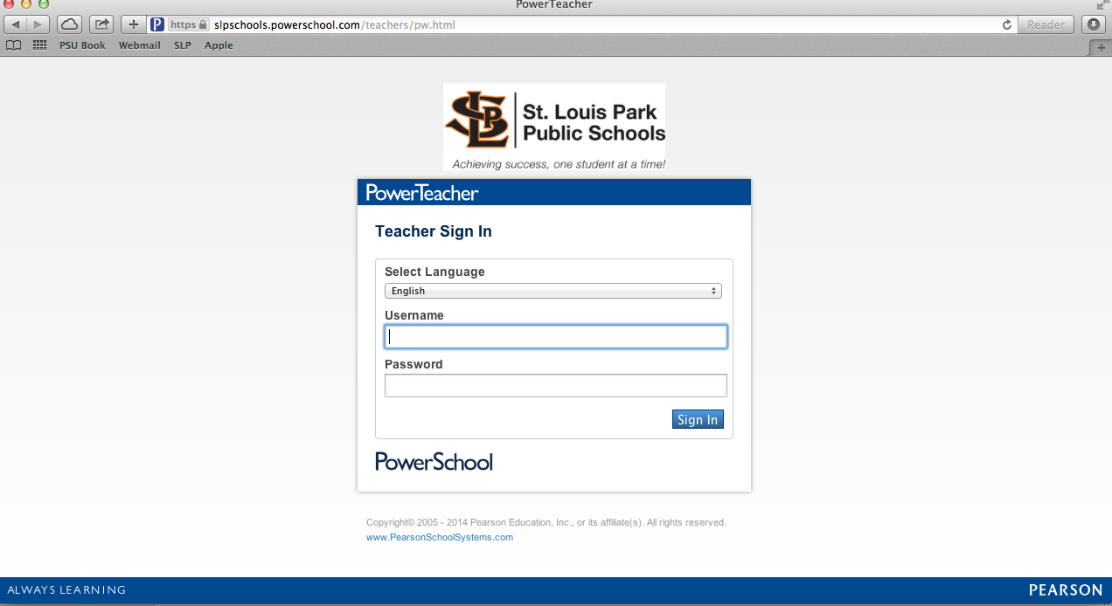
Username and password can be obtained from the athletic office.

Step 2. The start page will default upon start up.
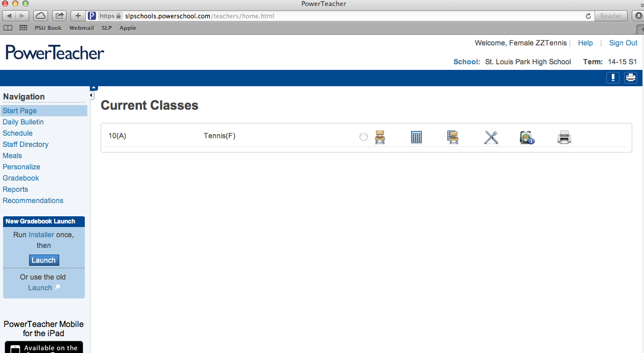

To view grades and attendance for athletes, click the backpack.

A list of the athletes will appear on the left. Click on a name. Quick Lookup is the screen where you can view grades and attendance. If Quick Lookup is not the default, click Select screens and choose Quick Lookup.
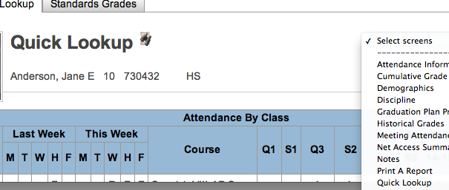
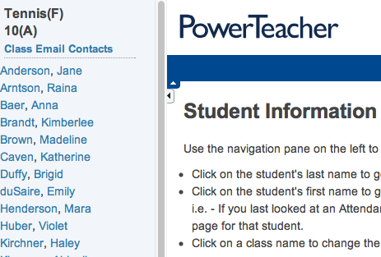

Student name

Step 3. To get the gradebook, where you will input awards, follow the directions in the attached document titled Installing PowerTeacher Gradebook.

Step 4.
The GRADEBOOK: Double click the Gradebook which you either saved on your desktop or on your doc. To log in, select St. Louis Park High School as the school. Type in the Username and Password given to you by the athletic department.

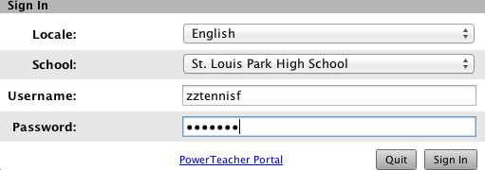

A. Make sure you are in the current year and term i.e. Current Classes (S1) You might have to scroll to the top to get to Current Classes.
This is what the athletic department will use to create certificates and maintain historical records of individual athletes throughout their athletic career. ACCURACY IS CRITICAL!!
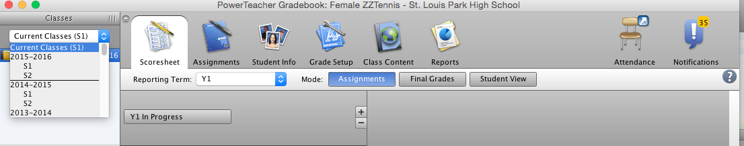

B. Very Important: Select the correct Reporting Term of Y1. If you select S1 or S2, the scores will not be able to be used and you will need to re-enter them in Y1.
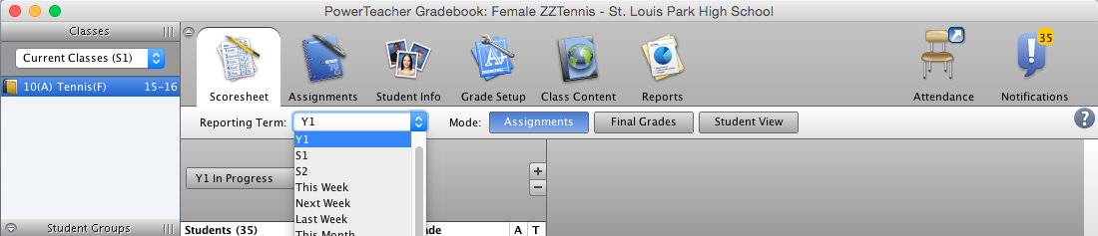

C. Select Final Grades for “assignments” to appear and to be able to do your recording.

D. You can adjust the Student Name Column by placing your cursor on the solid line between the Final Grade and the first assignment.
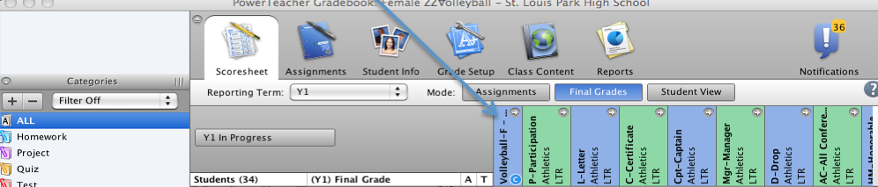

For the “assignments”, put in the appropriate letter(s) necessary to record the desired item. The letter(s) are listed for your convenience at the beginning of the “assignment” name.

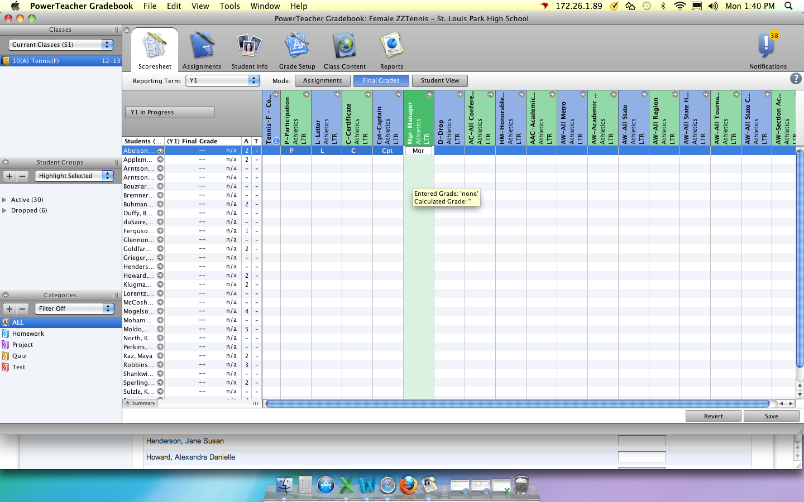
***ALWAYS CLICK SAVE AT THE BOTTOM OF THE SCREEN TO SAVE YOUR WORK.

When you are finished, click on Gradebook in the upper left corner and then select Quit Gradebook.

If you have any questions, feel free to contact Bridgid Hoppmann or Shawn Mathews in the Athletic Office.

