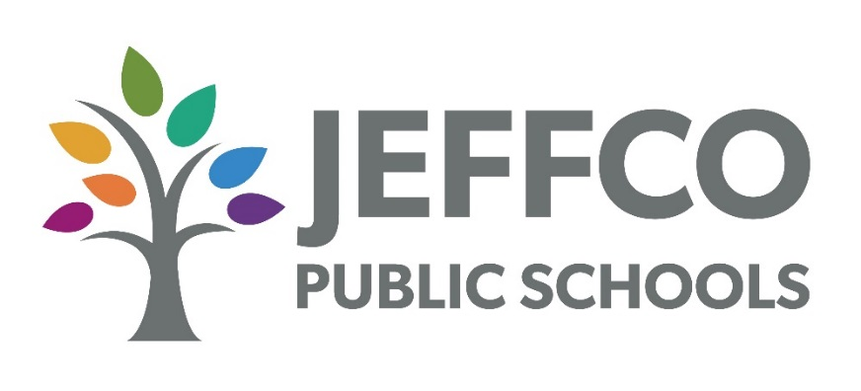
_____________________________________________________________________________________________________________________
Signage Sponsorship Agreement (Short Form)

NOTE: Per District policies, the School may NOT enter into sponsorship arrangements that involve certain activities, such as promote the use of drugs, alcohol, tobacco, or firearms; promote religious or political organizations; or promote or oppose candidates for election or ballot initiatives. For a full list of prohibited activities, please refer to District Policies KHB and KHBA.
This is an agreement (the “Agreement”) by and between Jefferson County Public Schools R-1 (the “District”), for the benefit of the following District school: (type name of school receiving sponsorship funds) ______________________________________ (the “School”), and (type complete legal name of sponsor) _____________________________________ (the “Sponsor”). The Agreement is effective from the later date of the parties’ signatures (the “Effective Date”) until and through June 30, ___ (type the year in which the current fiscal year ends).
- The District wishes to establish cooperative partnerships with local businesses, community members, and supporters to promote its students athletic and other extracurricular activities.
- The Sponsor wishes to contribute to the athletic and extracurricular success of District students.
- The Sponsor wishes to contribute for the following number of fiscal years (July 1 through June 30 of each calendar year), which includes a 9-months school year:
  - ☐ 1 year for a Sponsorship Fee of $500.
  - ☐ 3 school years for a Sponsorship Fee of $1,200 ($500 first year, $400 second year, $300 third year).
  - ☐ Other: ________________________________
- The Sponsor shall pay to the School the Sponsorship Fee as follows (check as applicable):
  - ☐ Fully and in advance, at the time of Agreement signing. (check when paid) ______
  - ☐ In installments (if $1,200 for 3 school years is elected):
(check when paid) ______ $500 upon Agreement signing
(check when paid) ______ $400 due on (insert due date): _____________________
(check when paid) ______ $300 due on (insert due date): ______________________
  - ☐ Other: __________________________ (check when paid) ______
- The Sponsor shall provide to the School a sign or other signage (the “Sign”) with content selected by the Sponsor and approved by the School, such as Sponsor’s name and logo.
- The measurements and content of the Sign shall comply with applicable laws and District policies, regulations, and procedures, including, without limitation, District Policies KHB and KHBA. The Sign will have the following specifications (check as applicable):
  - ☐ Measurements: ___ feet by ___ feet.
  - ☐ Other specifications (none if blank): ____________________________________________________________________________________________________________________________________________________________________________________________________________
- The Sponsor is fully responsible and liable for, indemnifies the District, and holds the District harmless and shall defend the District against, any claims relating to or arising from the Sign or the Agreement.
- The District will display the Sign at the following location or locations (check applicable):
  - ☐ At the School
  - ☐ At this location: _____________________________________
- The District will display the Sign during the following dates and times: ______________________________________________________________________. If this is blank, the District will display the Sign as the District determines.
- The Sponsor shall not use the District name or logo except as expressly permitted hereunder.
- At the end of the Agreement, the District may remove the Sign from its location and dispose of the Sign or return the Sign to the Sponsor, as the District in its sole discretion decides.
- The District may terminate the Agreement at any time if the District decides in its sole discretion that termination is in the District’s best interest. If the District terminates the Agreement for any reason other than Sponsor’s non-performance under this Agreement, the District will refund to the Sponsor, upon the Sponsor’s written request, the portion of any Sponsorship Fee already paid that is proportional to the number of days that remain under the Agreement if the Agreement would not have been terminated early. The District will not pay for lost profits.
- The District does not waive, expressly or implied, any of the immunities, rights, benefits, protections, or other provisions, of the Colorado Governmental Immunity Act or the Federal Torts Claims Act. This Agreement is subject to and the District will comply with the Colorado Open Records Act.

Signatures
- The parties agree to the terms and conditions set forth herein by signing below. Individuals signing on behalf of each party represent and warrant that they are authorized to execute this Agreement on behalf of the party for which they are signing.
The School Principal, or their designee
(i.e., Athletic Director) approve of this sponsorship.

SCHOOL APPROVAL:
________________________________
Name of School

_______________________________________
Signature of Principal or Designee

Name of Principal or Designee:
__________________________________

________________________, 20_____
Date of Approval
SPONSOR:  ____________________________________  _____________________________________  Signature  By: ______________________________________________  Name and Title of Person Signing for Sponsor  ______________________, 20_____  Date of Sponsor Representative Signature | DISTRICT:  Jefferson County School District R-1  _______________________________________  Signature  By: ____________________________________  Director of Purchasing or Designee  ________________________, 20_____  Date of District Representative Signature

